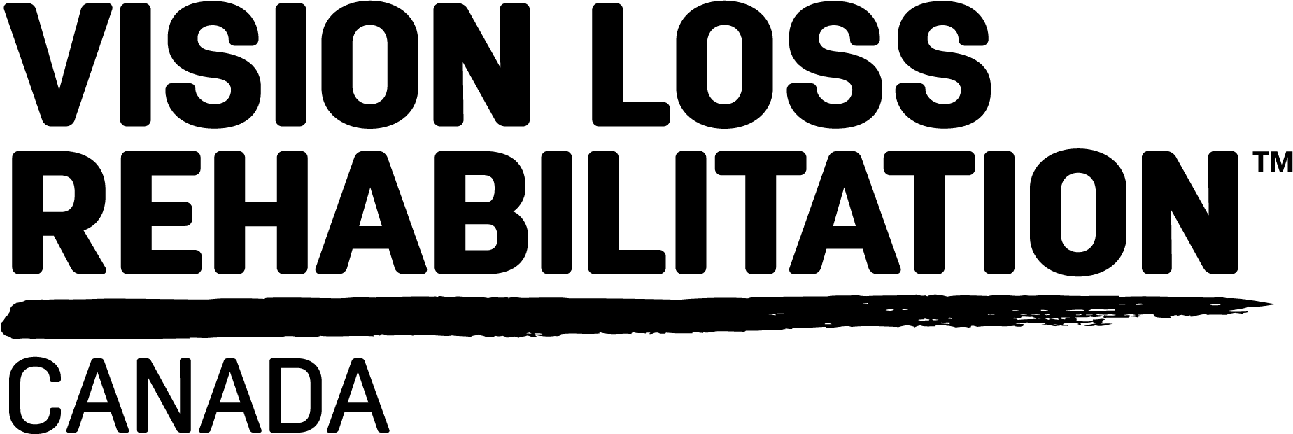

Building Accessibility for a Bright Future

Multi-Year Accessibility Plan Summary

Overview
Accessibility is a way of thought and means that we consider the needs of all stakeholders in an inclusive and holistic manner. As we embark on a new strategic plan with a strong focus on accessibility, it is imperative that VLRC continue to lead by example in this space. This means not only excelling in accessibility for external stakeholders, but equally for our colleagues – staff and volunteers.
Accessibility solutions are often common-sense practices that can be seamlessly integrated into organizational operations. VLRC's accessibility framework addresses the technical and attitudinal elements of accessibility, along with user and trainer competencies. The Multi-Year Accessibility Plan involves three (3) phases of implementation. Each phase includes initial activities and desired outcomes in realizing five (5) key objectives. Using this plan, VLRC will identify opportunities, measure progress and sustain best practices in accessibility.

VLRC Accessibility Commitment
Accessibility is our collective responsibility. We will dedicate the time and resources to accessibility so that every person is supported to be successful in their organizational role, obligations or community outreach.

Objectives
#1: Culture of Accessibility & Inclusive Workplace (aligned to Strategic Goal 4) – building an inclusive workplace framework.
Success Criteria:
- Establishment of an Accessibility Team led by the Chief Accessibility Officer.
- Establishment of the Accessibility Champions Network & Recognition Programs.
- Standardized reporting mechanisms on accessibility across VLRC (clients, employees & volunteers).
- Diversity & Inclusion represented in decision-making processes & roles across the organization.
- Accessibility needs, and solutions, incorporated into working process (e.g., extra time, team meetings, home visits, and travel arrangements).
- Increase in voluntary disability disclosure for all disabilities (including invisible disabilities).
#2: Education & Skills Development in Accessibility (aligned to Strategic Goal #4) – awareness education, engagement and technical training in accessibility
Success Criteria:
- Personalized training materials for disability awareness & sensitivity campaigns across multiple channels and platforms in the organization (online, surveys, narratives, in-person workshops).
- 100% employees complete and apply sensitivity & unconscious biases training at work.
- eLearning platform to collect relevant usage analytics and dashboard reports for accessibility courses.
- Employees and volunteers have access to training and educational course content in diverse learning styles & accessible formats.
#3: Integrated Accessible Technological Ecosystem (aligned to Strategic Goal #2) – integration of accessible technology platforms and equipment
Success Criteria:
- Building awareness and promoting usage of Microsoft’s Accessibility checker.
- Documentation & review of accessible procurement.
- Accessible external facing documents are produced according to user accessibility requirements.
- Staff, volunteers and clients have access to Assistive Technologies they require, in an accessible way.
- 100% AT & OCR software on all machines (institutional licence).
- All employee and volunteer tools, materials, platforms, etc. are accessible or have alternatives in place to achieve accessibility.

#4: Ensuring Physical & Environmental Accessibility (aligned to strategic Goal #2) – sustaining/promoting built environments and Universal Design innovations throughout VLRC
Success Criteria:
- Documented accessibility audits at lease renewals & renovations for remediation of known barriers.
- Innovative community & design partnerships.
- Spotlight & spread successful local design initiatives (accessibility gardens, Ibeacons, etc).
- Upgrading Innovative Universal Design features/standards.
- Establishing expert panel on wayfinding
- Modernizing Clearing Our Path Teaching Materials.
#5: Accessibility Monitoring & Evaluation (aligned to Strategic Goals #1 and #4) – building and implementing robust evidence-based accessibility practices and processes
Success Criteria:
- Finalization and dissemination of VLRC accessibility framework, commitment, criteria & standards.
- Establishment of Accessibility Hub & Portal
- Increase Disability Representation across organization (especially HR & upper managerial roles).
- Employees have greater control & awareness of accommodations (individual accommodation plans).
- Enhanced employee engagement and accessibility surveys for better tracking of workplace inclusion.
- A balance between standardization and person-centered accessibility measures / approaches.
- Process for requests to assess accessibility established and used organization-wide.

Phases of Implementation
Table 1
Phase | Initial Activities | Desired Outcomes
1  (2018-2019) | - Collect accessibility and inclusion statistics/activities  - Executive & Management Accessibility Statements  - Inclusive leadership and mentoring  - Policy reviews, updates, & creation  - Accessibility integrated into learning strategies  - Implementation of accessible VLRC University Learning Platform & content.  - User accessibility testing panel established. | Improved visibility and reporting on accessibility practices throughout the organization

2  (2019-2020) | - Research and development partnerships and collaborations in accessibility.  - System-wide usage analytics for accessibility documents/materials on Internal Portal.  - Technology accessibility standards taskforce and projects  - Accessibility Hub, Assessment Toolkit & Survey  - Digital software & systems evaluation and documentation  - Inclusive workplace best practice playbook | Accessibility integrated into organizational practices, decision-making and individual mindsets
3  (2020-2022) | - Foster experts in key areas (Digital Accessibility, Design, Built Environment and Transportation, Health and Social Inclusion)  - Training & educating youth and volunteers in the accessibility and advocacy in targeted training programs.  - Internal and external Disability Awareness Campaigns. | Dissemination of accessibility expertise & policy papers to society and key decision-makers  Community mobilization

