April 2025

Open letter to political leaders at all levels across Canada concerning Bill C-284
Hello,
As the Vision Health Partners Coalition, we are writing to request your party’s strong support for the implementation of Bill C-284, An Act to establish a national strategy for eye care. As you are aware, this legislation represents a significant step forward in addressing the critical issue of eye health in our country.
Eye care is an essential component of overall health and well-being. It is estimated that 1.2 million Canadians were living with vision loss and blindness in 2019. Incredibly, the total cost associated with this vision loss was estimated at $32.9 billion. The major components of cost include healthcare system costs ($9.5 billion), productivity and informal caregiving losses ($4.3 billion) and the value of reduced quality of life or loss of wellbeing ($17.4 billion). Looking at trends in population growth and aging, it is possible to project that the cost of vision loss in Canada will grow by over 70 per cent to $56 billion in 2050.
Moreover, research suggests that 1 in 3 Canadian adults have not sought vision care. Eye health professionals see an alarming rate of unattended eye diseases and conditions every day in their practices, including glaucoma, cataract, diabetic retinopathy and age-related macular degeneration. Yet, we know that 75 per cent of vision loss is preventable or treatable through proper preventative measures such as comprehensive eye exams.
The implementation of a national eye care strategy will ensure that we have a comprehensive and coordinated approach to eye care, which is crucial for preventing vision loss and improving the quality of life for millions of Canadians.
The Vision Health Partners are committed to working collaboratively with all parties to support the goals of Bill C-284. We believe that a national strategy on eye care will provide the necessary framework to address the growing burden of vision loss, promote early detection and intervention, research, and ensure access to high-quality eye care and vision rehabilitation services for all Canadians.
We urge you to continue to support the implementation of Bill C-284 and to prioritize eye health in your policy agenda. By doing so, you will be making a significant contribution to the health and well-being of Canadians and helping to prevent vision loss for future generations.
Thank you for your attention to this essential matter. We look forward to working with you to improve eye care for all Canadians.
Sincerely,
Vision Health Partners Coalition
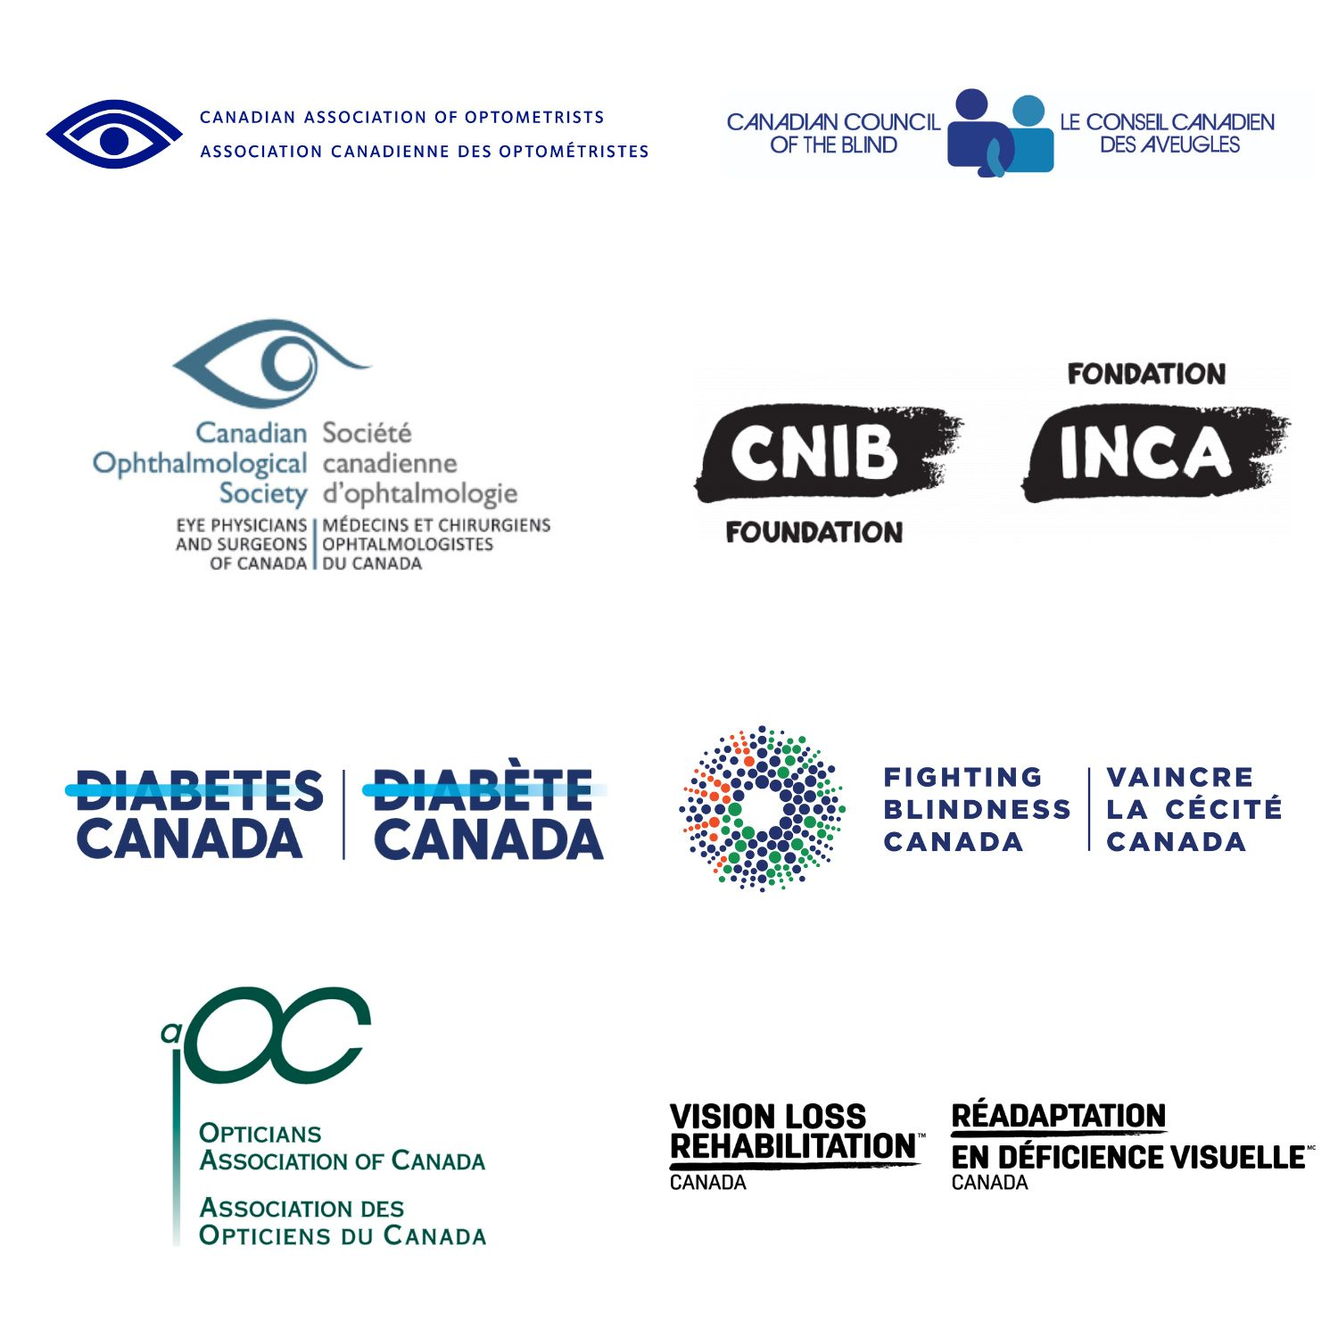
Vision Health
Partners Coalition

